Data science –

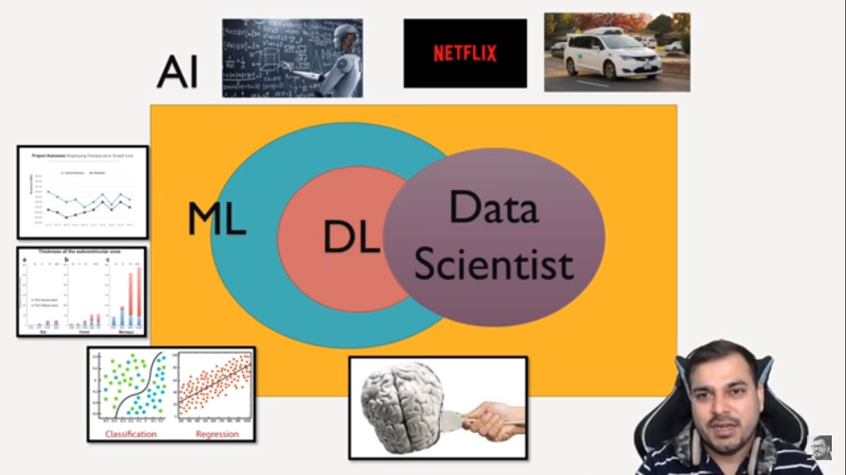

Work of Data Scientist –

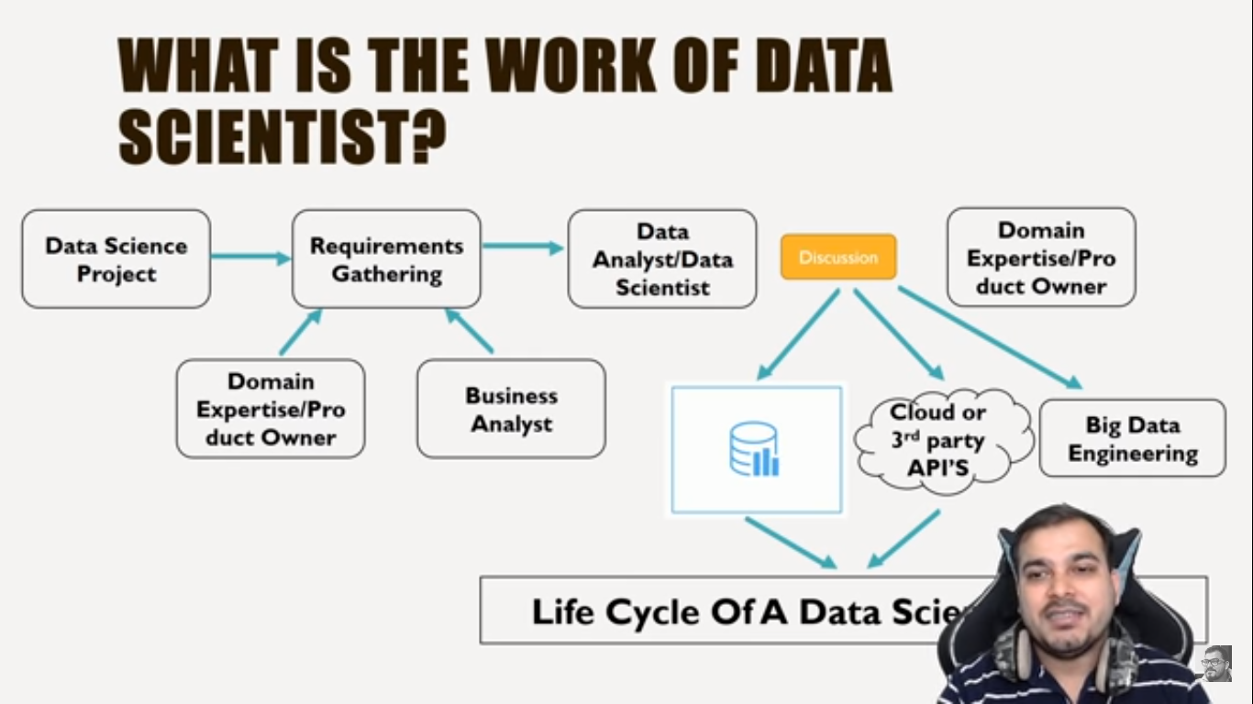

Definition –

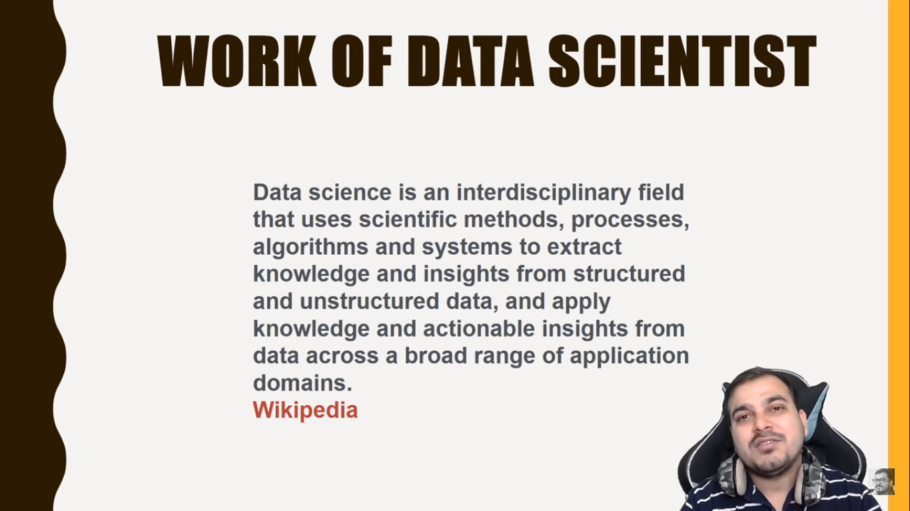

Life cycle of Data science project

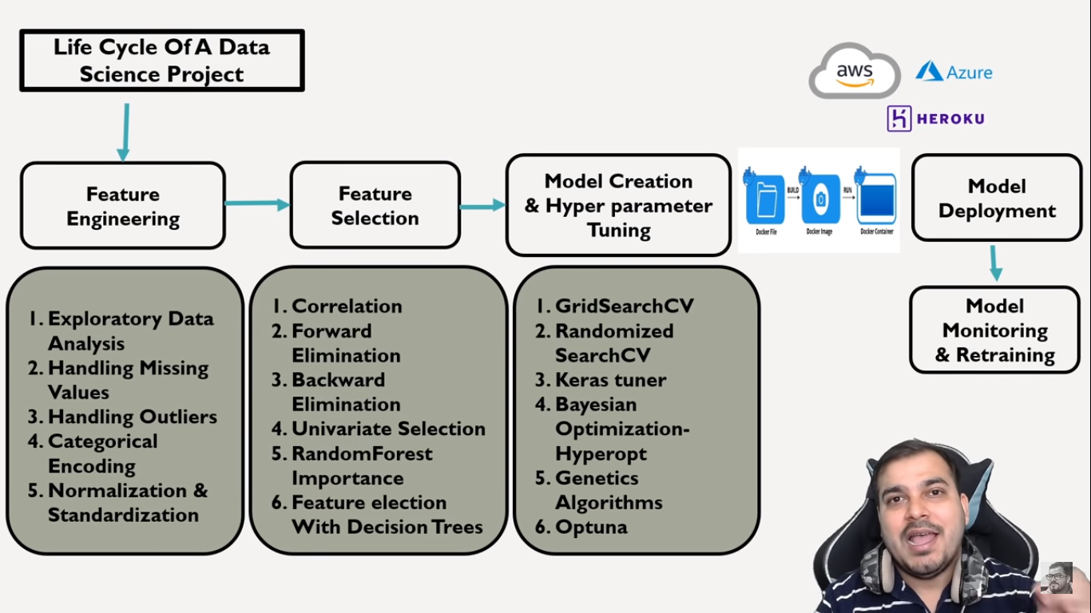

Roadmap for Data science

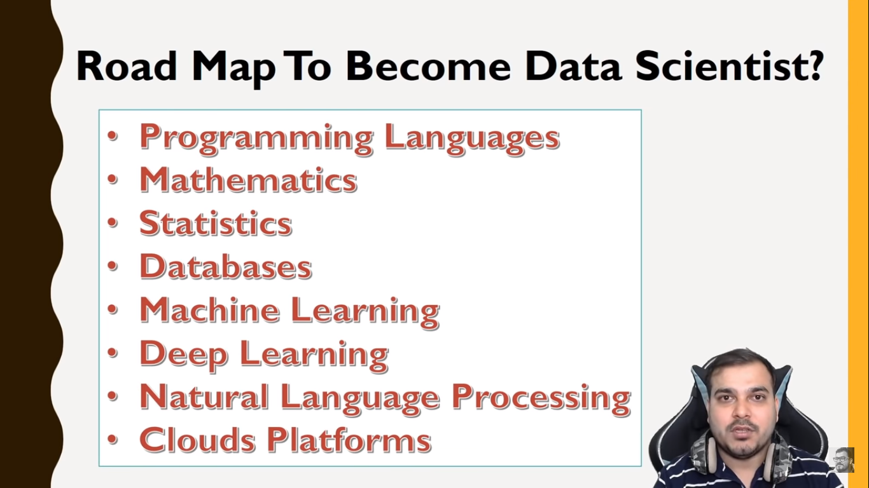

1. Programming language – Python or R
2. Mathematics –

* Calculus
* Linear Algebra
* Statistics

1. Statistics –

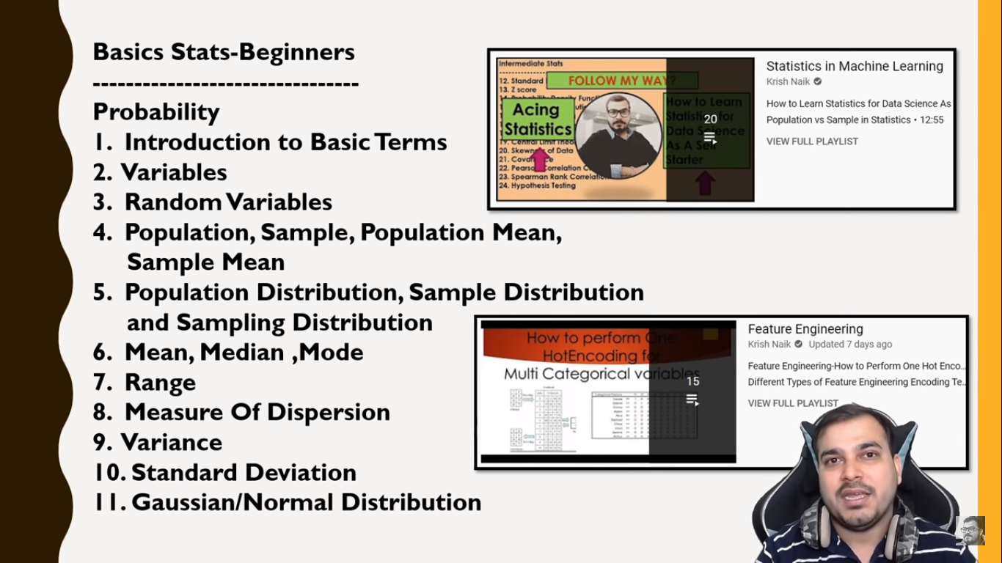

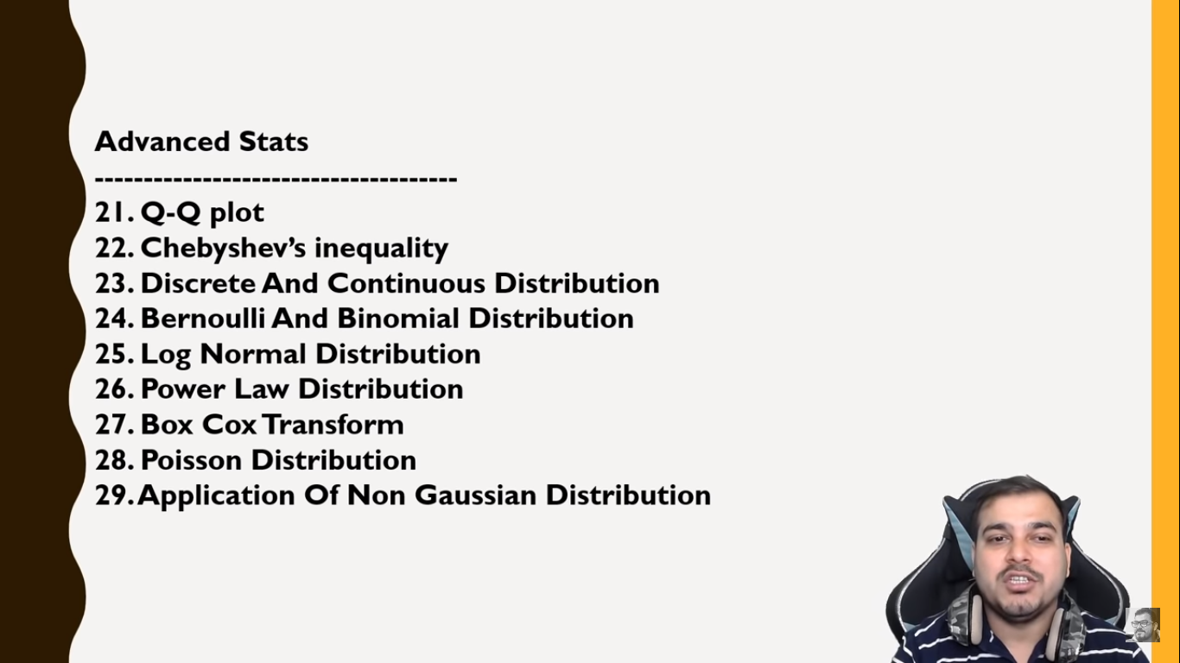

1. Databases

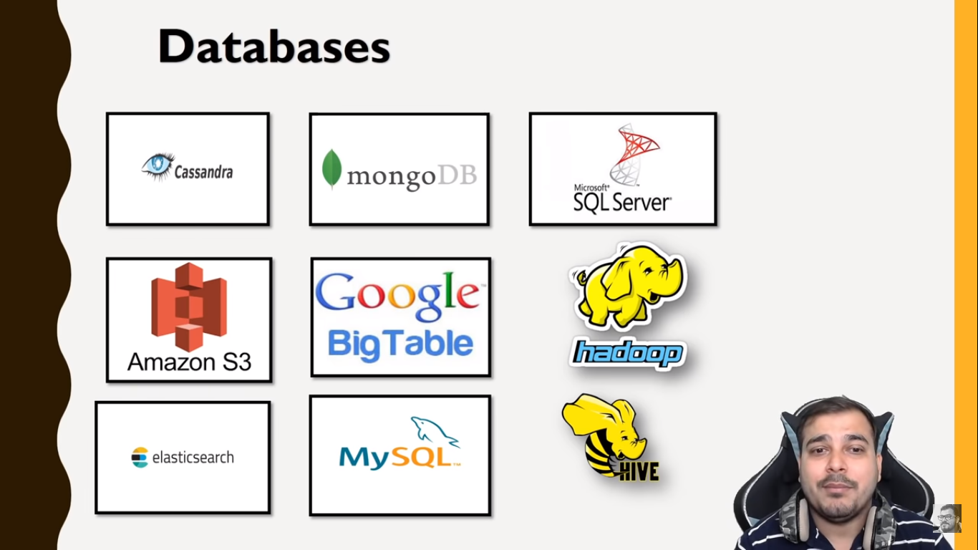

1. Machine learning –

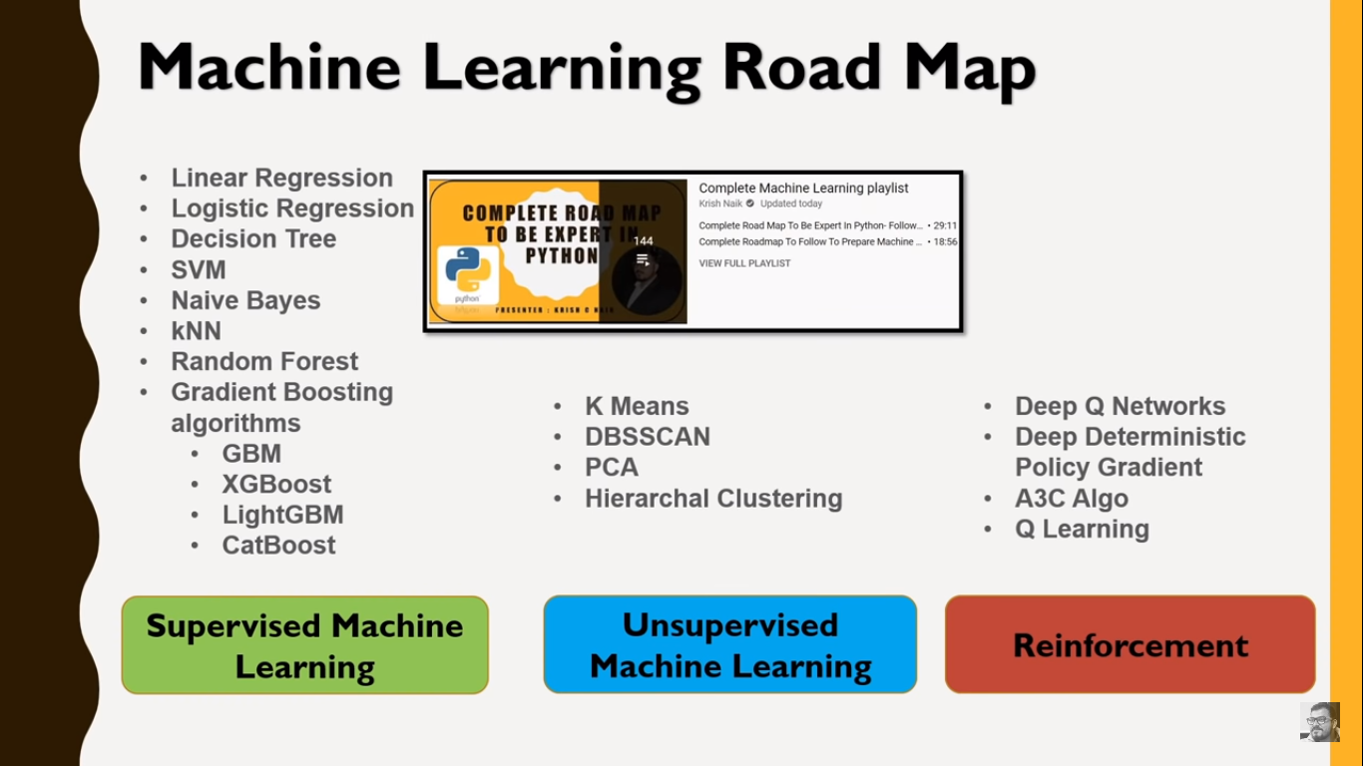

Roadmap ML

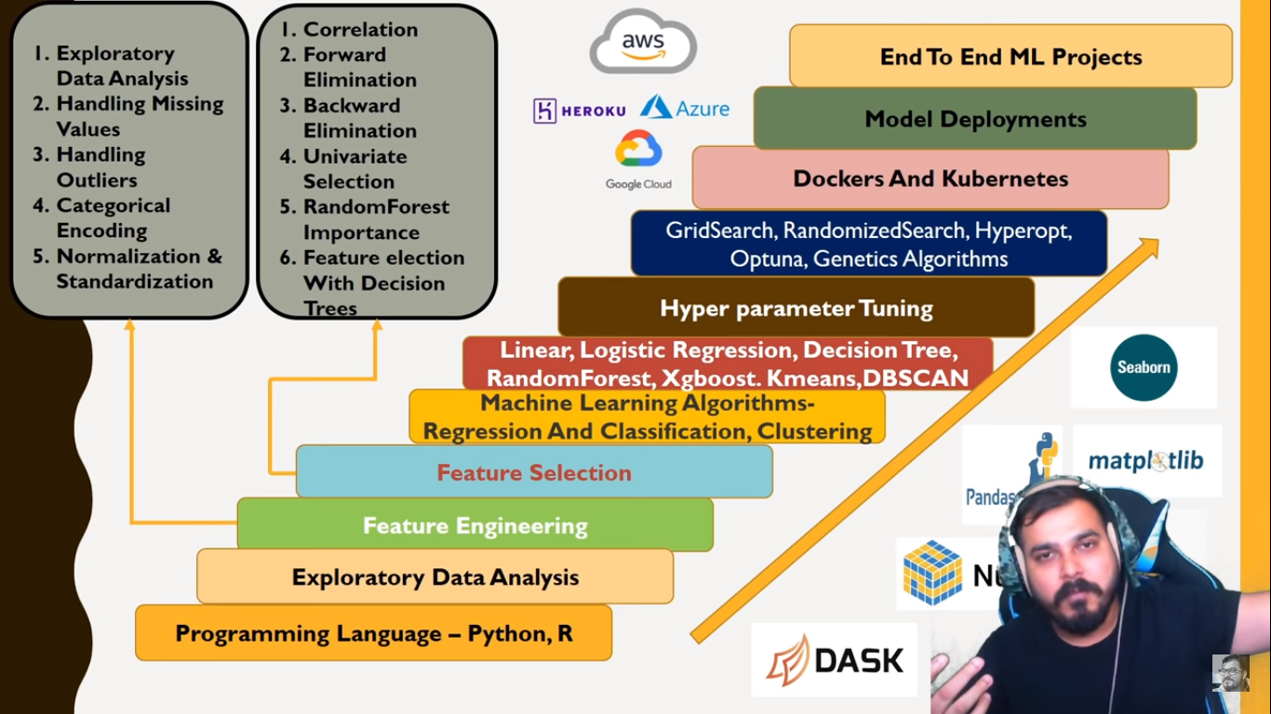

1. Deep Learning –

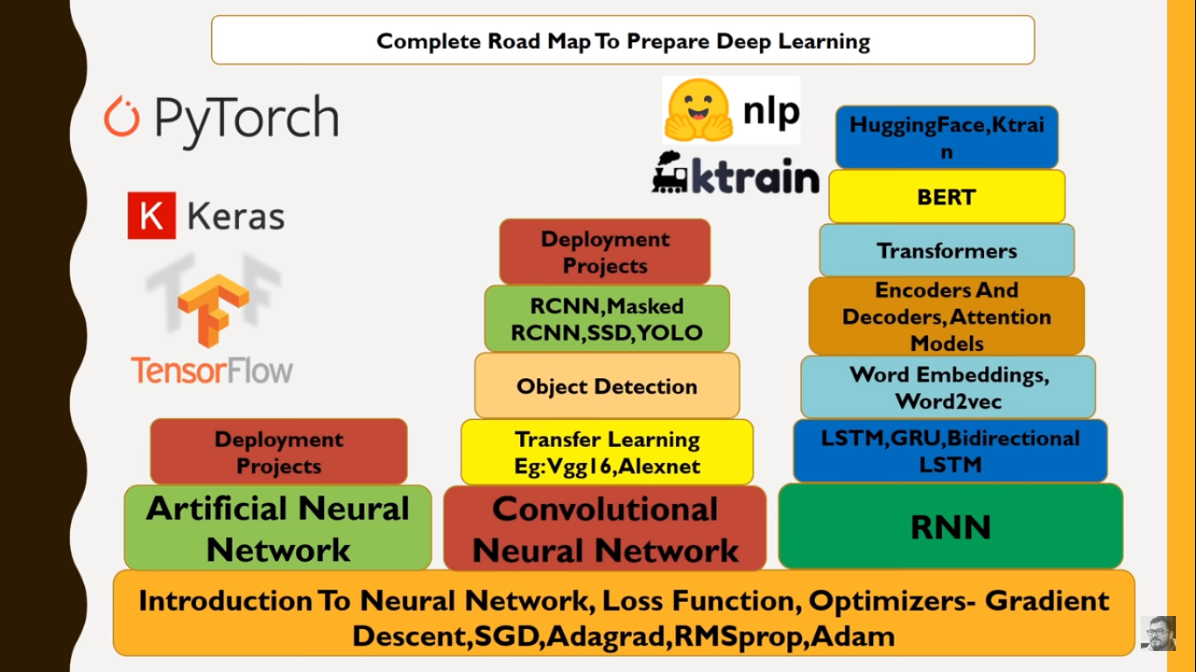

1. NLP –

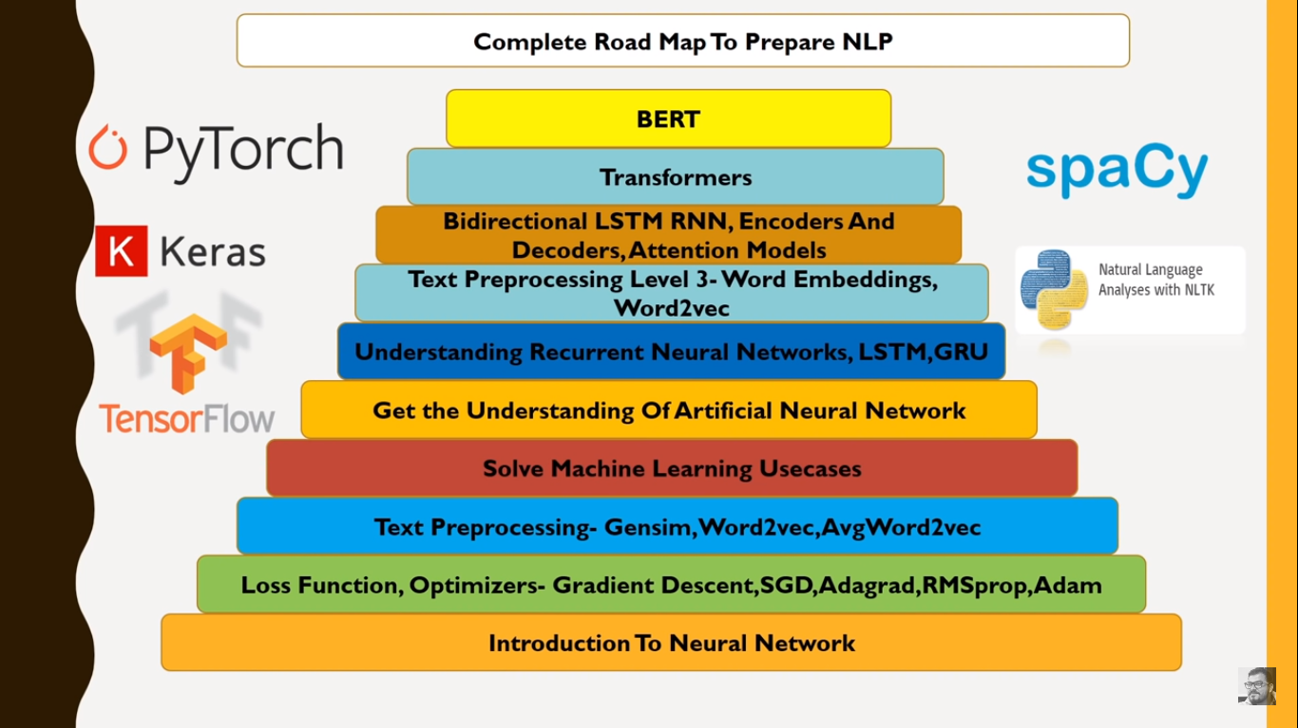

Roadmap NLP

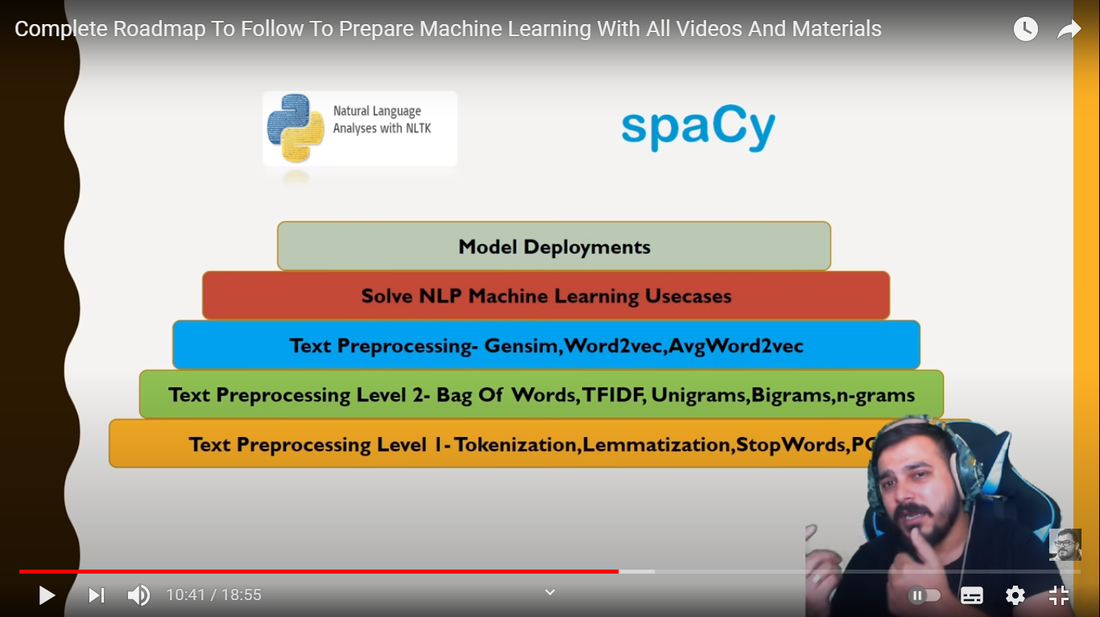

All frameworks for ML –

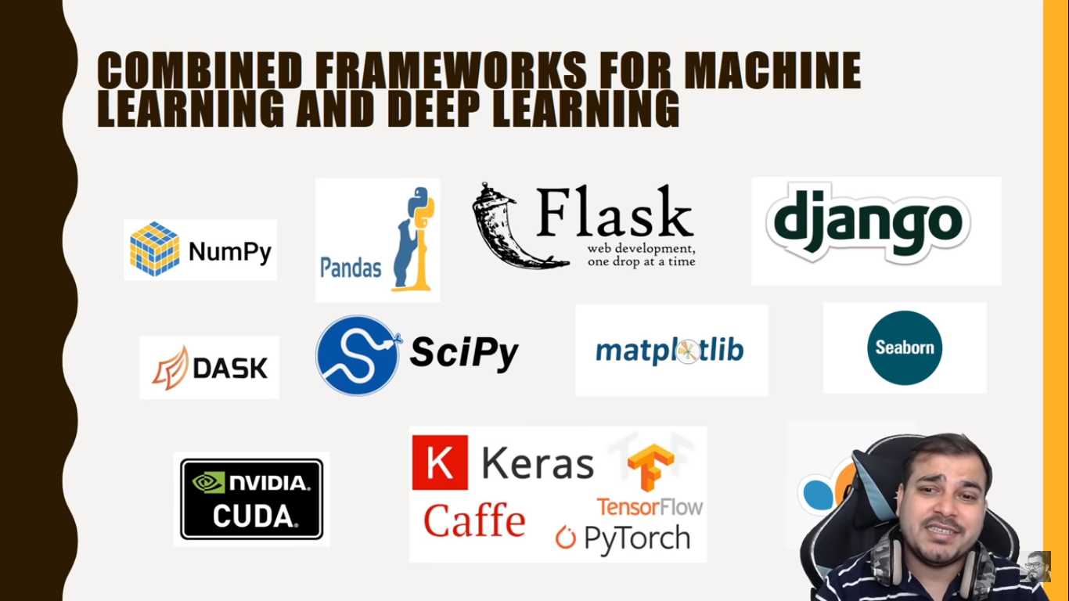

All frameworks for Web Development –

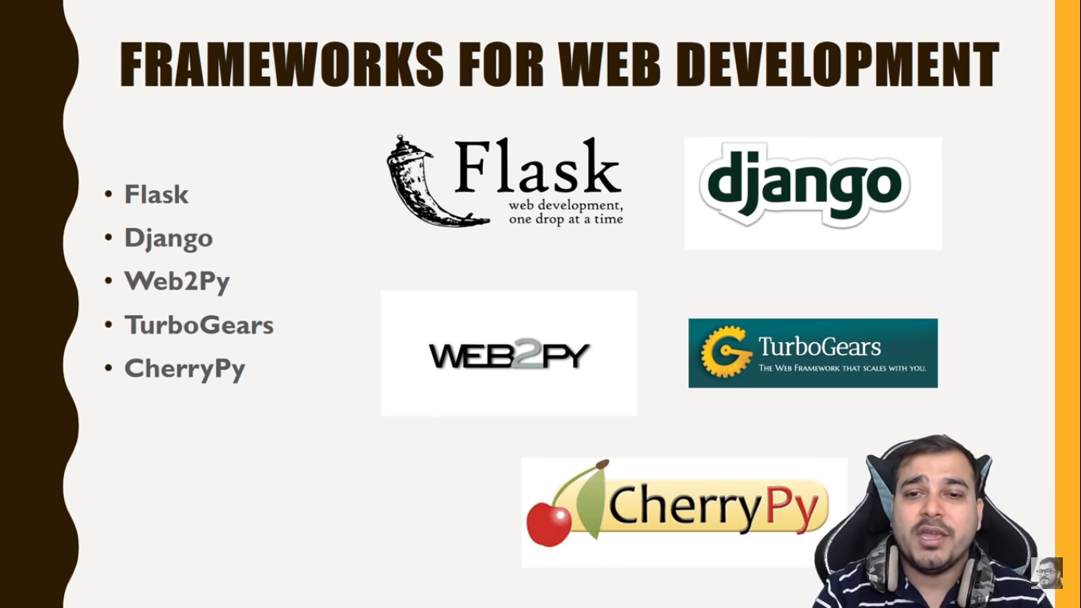

Playlist to follow –

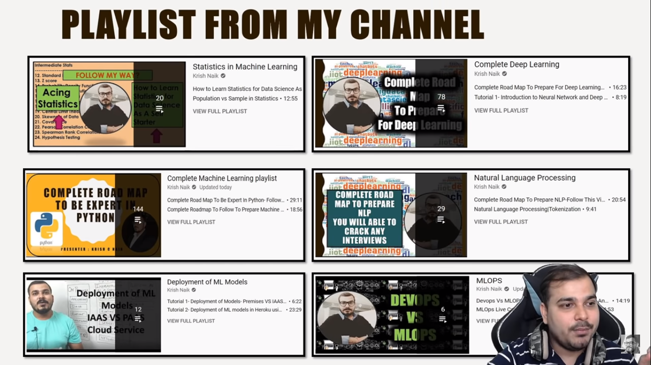

Cloud Platform –

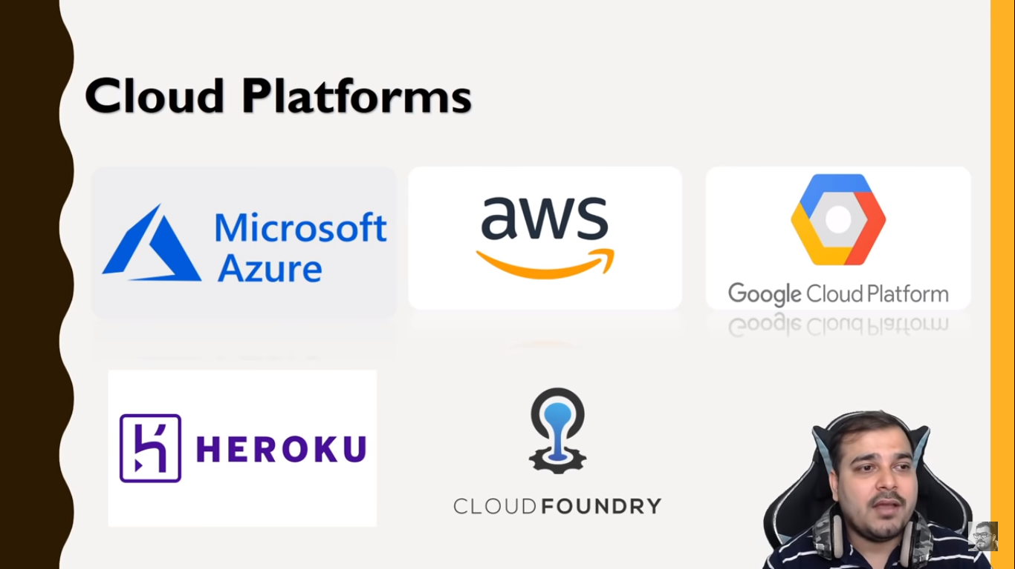

Playlist links –

All Playlist In My channel

1. Complete ML Playlist :[https://www.youtube.com/playlist?list...](https://www.youtube.com/playlist?list=PLZoTAELRMXVPBTrWtJkn3wWQxZkmTXGwe)
2. Complete NLP Playlist: [https://www.youtube.com/playlist?list...](https://www.youtube.com/playlist?list=PLZoTAELRMXVMdJ5sqbCK2LiM0HhQVWNzm)
3. Docker End To End Implementation: [https://www.youtube.com/playlist?list...](https://www.youtube.com/playlist?list=PLZoTAELRMXVNKtpy0U_Mx9N26w8n0hIbs)
4. Live stream Playlist: [https://www.youtube.com/playlist?list...](https://www.youtube.com/playlist?list=PLZoTAELRMXVNxYFq_9MuiUdn2YnlFqmMK)
5. Machine Learning Pipelines: [https://www.youtube.com/playlist?list...](https://www.youtube.com/playlist?list=PLZoTAELRMXVNKtpy0U_Mx9N26w8n0hIbs)
6. Pytorch Playlist:

[https://www.youtube.com/playlist?list...](https://www.youtube.com/playlist?list=PLZoTAELRMXVNxYFq_9MuiUdn2YnlFqmMK)

1. Feature Engineering :[https://www.youtube.com/playlist?list...](https://www.youtube.com/playlist?list=PLZoTAELRMXVPwYGE2PXD3x0bfKnR0cJjN)
2. Live Projects :

[https://www.youtube.com/playlist?list...](https://www.youtube.com/playlist?list=PLZoTAELRMXVOFnfSwkB_uyr4FT-327noK)

1. Kaggle competition :[https://www.youtube.com/playlist?list...](https://www.youtube.com/playlist?list=PLZoTAELRMXVPiKOxbwaniXjHJ02bdkLWy)
2. Mongodb with Python :[https://www.youtube.com/playlist?list...](https://www.youtube.com/playlist?list=PLZoTAELRMXVN_8zzsevm1bm6G-plsiO1I)
3. MySQL With Python :[https://www.youtube.com/playlist?list...](https://www.youtube.com/playlist?list=PLZoTAELRMXVMd3RF7p-u7ezEysGaG9JmO)
4. Deployment Architectures:

[https://www.youtube.com/playlist?list...](https://www.youtube.com/playlist?list=PLZoTAELRMXVOPzVJiSJAn9Ly27Fi1-8ac)

1. Amazon sagemaker :[https://www.youtube.com/playlist?list...](https://www.youtube.com/playlist?list=PLZoTAELRMXVONh5mHrXowH6-dgyWoC_Ew)